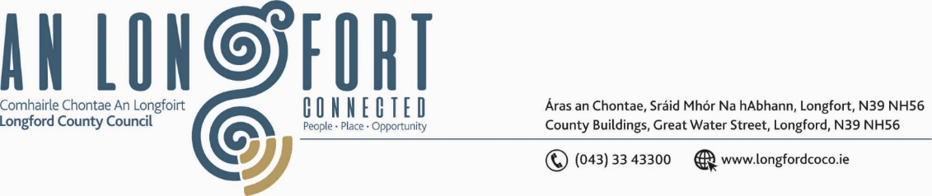

**GRANARD MUNICIPAL DISTRICT**

***Please note meeting will be held via Microsoft Teams.***

**19th May 2021.**

**To: Each Member of Granard Municipal District.**

**Dear Member,**

You are requested to attend Meeting of Granard Municipal District to be held

**via Microsoft Teams** on **Tuesday, 25th May 2021 at 3.30pm**.

to transact business, as set out on the Agenda hereunder.

**Yours sincerely**,

Ann Marie Mc Keon

______________________

**Ann Marie Mc Keon,**

**Meetings Administrator.**

**AGENDA**

Prayer before meeting.

**1.** Confirmation of Minutes as follows: -

* Granard Municipal District Committee Meeting held on 23rd March 2021 – copy enclosed.
* Granard Municipal District Meeting held on the 23rd March 2021 – copy enclosed.

**2.** Matters arising from Minutes.

**3.** Declaration of Interest by Members.

**4.** Management Report incorporating Area Engineer’s Progress Report

- enclosed.

**5.** Granard Public Art Features.

**6.** Consideration of applications for funding under the 2021 Community Grant

Support Scheme - list enclosed.

**7.** Special Projects Funding / Discretionary Grants 2021.

**8.** CCTV – Granard - Presentation by Daniel Lynch.

**9.** Notices of Motions, submitted by Councillors, as listed hereunder –

**Councillor PJ Reilly**

“I call on Longford County Council to provide an update on when funding will be allocated for safety and realignment works at the Perth cross junction”.

**Councillor PJ Reilly**

I wish to put a Motion to the Meeting for the Council to write to Irish Water for funding to replace the Water Line at Ballywillan/Creevy as there have been five major bursts within three days recently on this line causing major disturbance.

**Councillor Turlough Mc Govern**

That Longford County Council contact the relevant State Body (Coillte or Board Na Mona) to cut their trees on the R395 between Clonca and Coolamber area as they are overhanging(and some are ready to fall) onto the road and falling debris could cause an unnecessary accident.

**Councillor Colin Dalton**

I am calling on Longford County Council through the regeneration team, to support Naomh Columba National School, for funding under the safe routes to school program, to connect the school, church and community centre in the village via a footpath and the associated traffic calming measures.

**Councillor Colin Dalton**

I am calling on Longford County Council to prioritise safety measures at the junction where the France road meets the Clonbroney/Edgeworthstown road. There has been ongoing calls from the wider community to have this dangerous junction addressed. High volumes of traffic from the north of the county are commuting to and from Dublin every day and are using this route to access the N4 and the Mostrim Train station. I am imploring Longford County Council to give serious consideration to developing this junction, to improve the sight lines at the junction, before there is a serious or fatal accident.

**Councillor Garry Murtagh**

I call on Granard Municipal District to write to the Minister for transport Eamon Ryan to act swiftly and address the growing concern for people trying to access The Driver Theory Test.  Truck/Bus, CPC & Professional Theory Test exams are available via Pro Proctor Online Testing and the same service should be made available to people to complete the driver Theory Test (via an online portal).  There are young people playing a vital role in essential services that cannot complete their Theory Test as there are young people in the Agricultural sector in the same predicament.  Time and time again through-out the pandemic people have seen their appointments cancelled which is causing undue stress, concern and a serious back log on the system. Where simple solutions should be made available.

**10.** Correspondence from Bank of Ireland – copy enclosed.